AQUAPONICS DESIGN METHODOLOGY
Student Name
Institution
Course Name/Number
Due Date
Instructor Name

DESIGN IDEAS
The concept behind this Aquaponics project is to develop an engineering-based solution that tackles the social, legal, political, economic, environmental, technical and technological problems in the society by introducing a concept that meets the United Nations Development program (U.N.D.P) sustainable goals. It does this by addressing the energy concerns, population growth, pollution and water usage as maintained in the Industry, Infrastructure, sustainable cities, climate action and clean energy, U.N.D.P sustainable goals. The approach is to introduce an electronically-controlled Aquaponics module that works to power the motor used to run the back-yard farm that houses both fish and vegetables.
The current Environmental, Social and Financial challenges in the continent are that countries have a struggle with;
- Water usage.

Drought is a global challenge. Additionally, the increase in population, especially in urban areas, concerns water and sewage companies. Apart from the recycling, it is vital to conserve water effectively. The Aquaponics system takes care of this by using the recirculating technique that minimizes the need to add water into the system continually. Different from the conventional aquaculture systems that use ponds, the Aquaponics system uses tanks with a fish capacity closer to those in these fish ponds. Not to mean that the system is water efficient since leakages in tanks and plants' water absorption reduce the water capacity in the system. However, in rearing fish, the Aquaponics system is the sustainable way of using very little water.
- Pollution.

Traditional farms depend on dwindling fossil fuel products, unlike the Aquaponics case that combats global warming challenges by minimizing carbon dioxide emissions. For instance, in vegetable farming, where farmers need to farm tomatoes, the soil preparation process using tractors consume diesel, unlike in this backyard aquaponics system. Apart from air, noise pollution does occur in industries in fish processing and manufacturing. Generally, to solve pollution issues, it is vital to bring farms in the domestic household.
- Population growth.

The World's population continues to grow from the current 6.8 Million to 9 Billion in the coming 30 years; therefore, to feed this growing population, there is a need to provide the population by bringing the food closer sustainably. This backyard Aquaponic unit brings the food closer to the consumer's backyard. By tapping into the urbanization rate and the real-estate sector's growth, these aquaponic units solve the food security, energy, climate change, and population growth problem.
- Electrical Energy.

The demand of electricity increases with the proliferation of electronic products either in the industry, commercial or residential units. Therefore, it is imperative to introduce a sustainable technique to deal with the crisis through intelligent-based control systems. In Aquaponics, food and electrical energy becomes "decentralized," that makes the end-users manufacturers of electrical energy that helps in dealing with the future electrical demand.

DECISION MATRIX
Automated Aquaponics that use analog components using a Op-Amps and resistors, smart systems through microcontrollers or microprocessors and Internet of Things using either mobile applications and websites. Choice 1 involved an aquaponics system built with plywood, fish tanks and growth-beds with automated alerts and electronic monitoring capabilities using ultrasonic, light, temperature and motion sensors (Miller, 2015). Choice 2 sought to develop an artificially intelligent irrigation system using wireless sensor network and a CC2430 microcomputer that monitored the humidity and temperature changes that synched the results to an I.O.T platform (Duan, 2014). Choice 3 involved a photovoltaic solution that provided power supply to the microcontroller, and the pump
CRITERIA | CHOICE 1 | CHOICE 2 | CHOICE 3
Sensors (Light Detection, Water level monitoring, Temperature) | Ultrasonic (Water Level), Light sensor, Temperature sensor, Motion) | Flow, rain and humidity sensors. | Temperature, Moisture, Light Dependent Resistor (L.D.R)
Electronic Components | DC Converter, Breadboard cables, Capacitors, Resistors. | MCU, Solenoid valves, relays | Relay Driver circuit,
Microcontroller | Not Applicable | CC2430 Single Chip Microcomputer | PIC18F4550
Architecture | Fish Feeder, Automatic Siphon. | Automatic Irrigation: Xbee Networks, Fuzzy Control Algorithm | Aquaponics
Alert Triggering mechanisms | Liquid Crystal Display and L.E. Ds | IoT infrastructure | Liquid Crystal Display and L.E. Ds
Project Budget | $943.42 | $1512 | $323.42

IMPACT OF THE PROJECT
The advantage of this system is that it consumes a small space that makes it suitable for urban and peri-urban areas by supplying end-consumers with vegetables. Additionally, it conveys a vegetative improvement for the eco-system by improving the quality of life for the individuals through better sustainable homes that have a self-sufficient capability. The LED lighting in the setup also offers a better aesthetic outlook for the quality of life while the customized alert mechanism offers users with better monitoring and control of electronic appliances. Therefore, on a wider scope this project has a contribution to the economic, social, environmental and technological growth of all countries in meeting the global sustainable development goals.

DESIGN APPROACH
The following figure shows the mechanical structure of the plastic enclosure that houses the electronic component in this Aquaponics project.

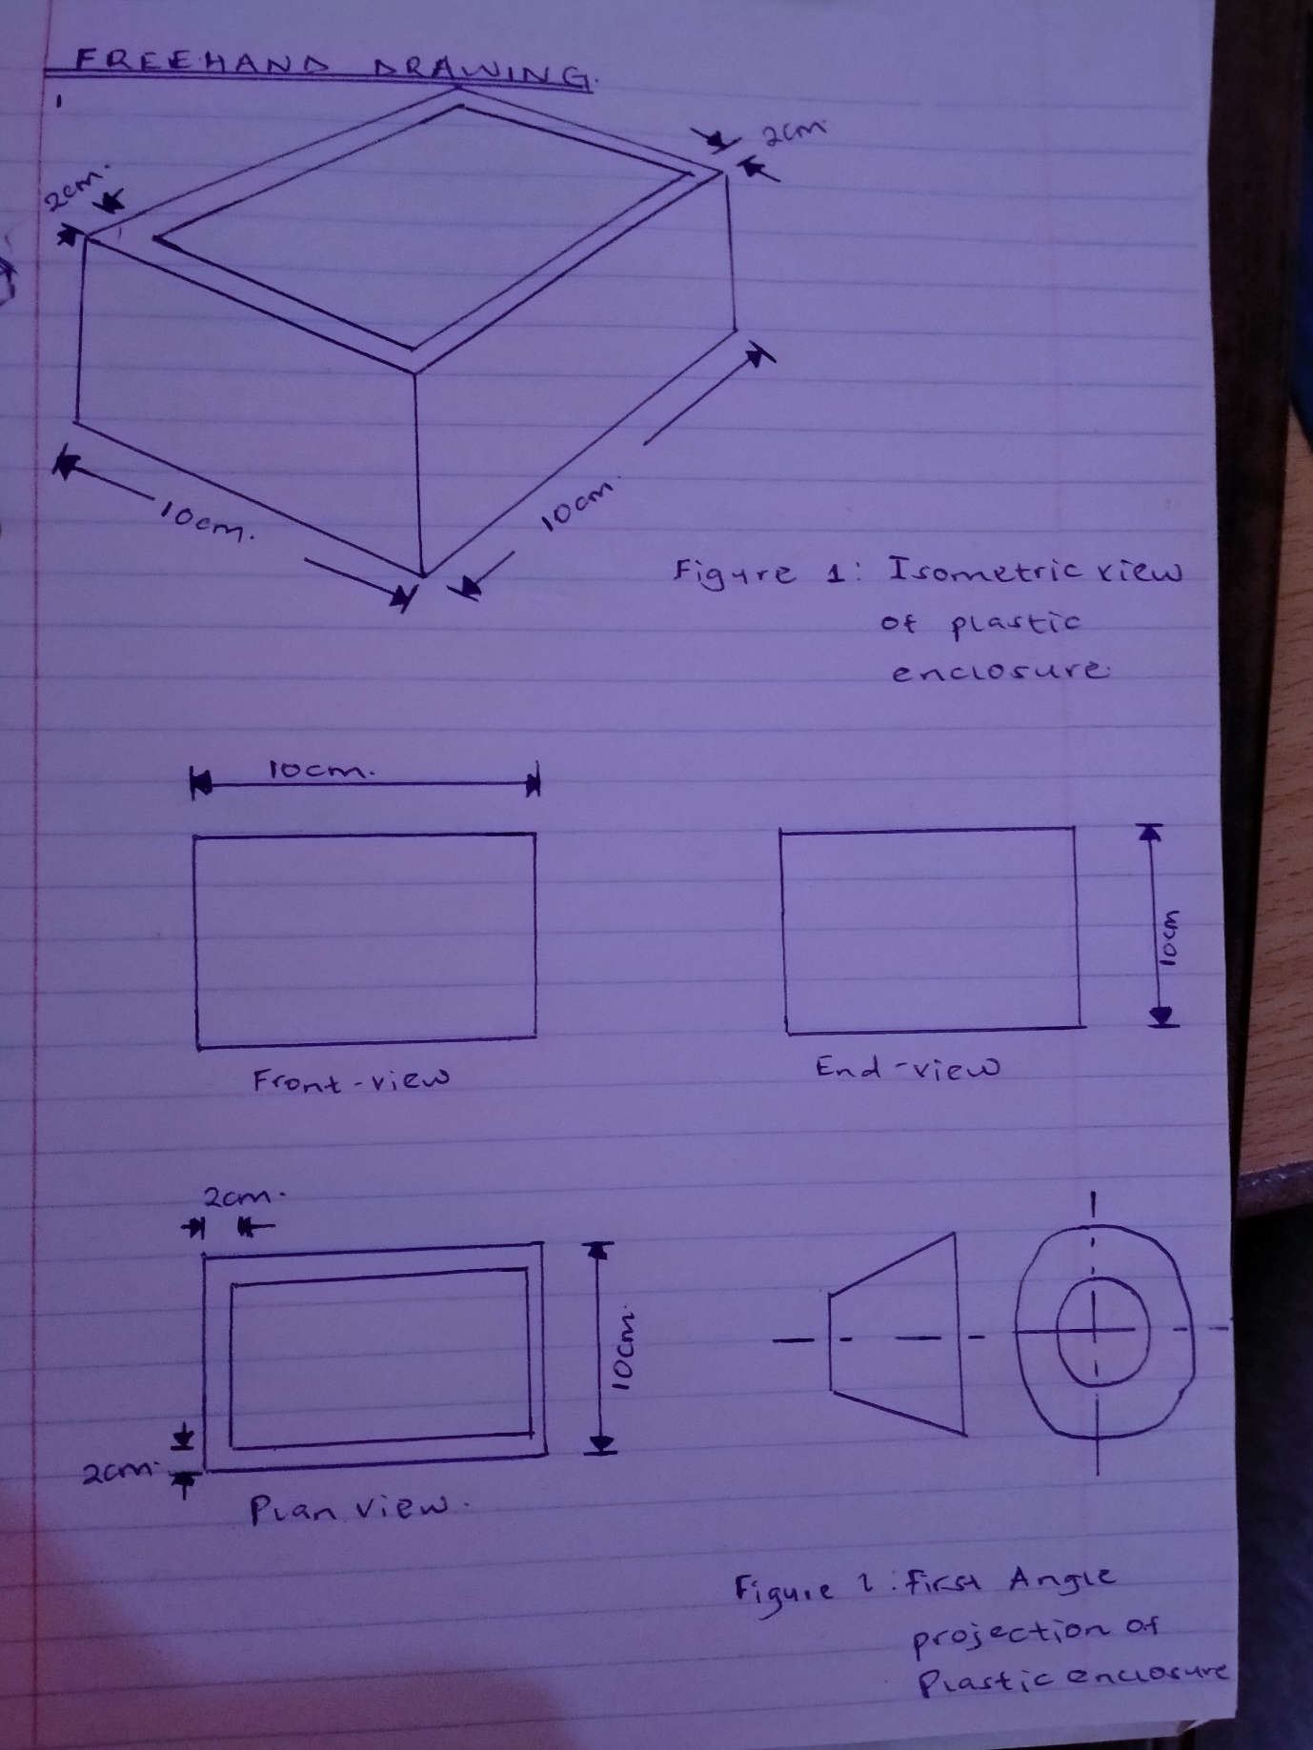

REFERENCES
Duan, X. J. (2014). Research on IOT-Based Smart Garden Project. In Applied Mechanics and Materials (Vol. 608, pp. 321-325). Trans Tech Publications Ltd.
Miller, C. (2015). Automated Aquaponics Design Report.
Murugesan, S., Priyanka, P., Snehal, S. M., & Amruta, M. (2017, December). Micro controller based automatic aquaphonic system using solar. In 2017 International Conference on Intelligent Sustainable Systems (ICISS) (pp. 43-47). IEEE.

